Options Application Companion to the FAFSA

(with screenshots)

The Free Application for Federal Student Aid (FAFSA) is the most important financial aid application; it is the main application for federal grants and loans as well the basis for both New York State and private college grants. All students eligible to file the FAFSA should do so, even if they don’t think they will receive federal aid. Many colleges use information from the FAFSA to allocate their own financial aid funds.

Purpose:
To determine the Expected Family Contribution (EFC) by gathering financial information about the student and, for dependent students, his or her family. The federal government and colleges and universities use the EFC to determine the student’s eligibility for various forms of financial aid.

General Application and Eligibility Information:
- The FAFSA application is available on-line at www.fafsa.ed.gov or www.fafsa.gov.
It is also available in paper; however applying on-line is easier and faster.
- Students who are college freshman candidates for the upcoming fall semester are eligible to file the FAFSA on or after January 1st. For example, January 1, 2014 for the 2014-2015 school year.
- Many colleges have priority filing deadlines between January 15 and February 15. Students and parents need to file the FAFSA as early as possible after January 1st to be eligible for the maximum amount of aid they may qualify for.
- A student should fill out the FAFSA if:
  - The student is eligible for federal financial aid: U.S. Citizens, Permanent Residents (Green Card Holders), Refugees/Asylees, Parolees, Victims of Human Trafficking, and Cuban-Haitian Entrants,
  - The student is not eligible for federal aid but eligible for college institutional aid: Student Visa Holders, F-1 or 2; Exchange Visitors, J-1 or 2 visa holders; G-series visa holders. If a student is undocumented, he/she should not file the FAFSA.
- The federal helpline (1-800-4-FED-AID) is an important resource for questions about the FAFSA.
USING THIS DOCUMENT:
The notes are organized by the sections of the on-line FAFSA.
The screenshots on the right will have corresponding notes on the left.

Before Applying:

- Get PIN numbers
- Students and parents need personal identification numbers (PIN) to complete the FAFSA on-line. The PIN is a four digit code that is used as an electronic signature. It decreases the processing time and can be used to make corrections, update and get access to the FAFSA renewal form in subsequent years.
- If a student is considered dependent, both student and parent(s) need to request PINs. If a student is considered independent (see “Dependency Determination” section), only the student needs to request a PIN.
- To request a PIN, the student and/or parent needs to provide a name, date of birth and social security number. A student or parent can request a PIN on-line at www.pin.ed.gov prior to filling out the FAFSA or apply for it while filling out the FAFSA.
- Parents without social security numbers will not be able to apply for a PIN. To sign the form, they should print out a signature page, sign it, and send it in the mail.
- Collect Documents
Student should collect:
- Alien registration number or permanent residence card (if not a U.S. citizen)
- Driver's license (if any)
Student (and Parent(s) for dependent students) should also collect:
- Social Security Number (can be found on Social Security card)
- Financial documents*:
- W-2 Forms and other records of money earned for the year preceding
- Federal Income Tax Return* - IRS Form 1040, 1040A, 1040EZ, foreign tax return, or tax return for Puerto Rico, Guam, American Samoa, the U.S. Virgin Islands, the Marshall Islands, the Federated States of Micronesia or Palau
- Untaxed income records - Social Security, Temporary Assistance to Needy Families, welfare, or veterans benefits records
- Most recent bank statements
- Most recent business and investment mortgage information, business and farm records, stock, bond, and other investment records
* In applying for the 2014-15 school year, using 2013 documents is ideal. In order to meet the priority financial aid filing dates, families may use their 2012 documents to estimate their finances and update their FAFSA as soon as the new documents are ready.

LOGIN

- Any time a question refers to “you” or “your,” it is referring to the student
- Students must have valid social security numbers in order for their FAFSA to be processed. If a student does not have a valid social security number, it is a flag that the student may be undocumented. Support the student to completely clarify their status before filing the FAFSA. Undocumented students should not submit the FAFSA.
- Students must enter their names exactly as they appear on their social security cards or FAFSA will send them a message that their application cannot be processed until the discrepancy is corrected.

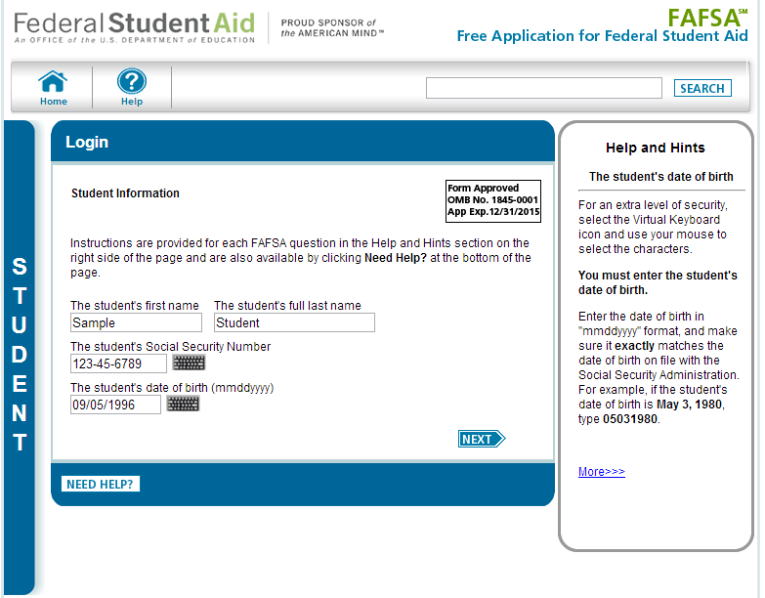

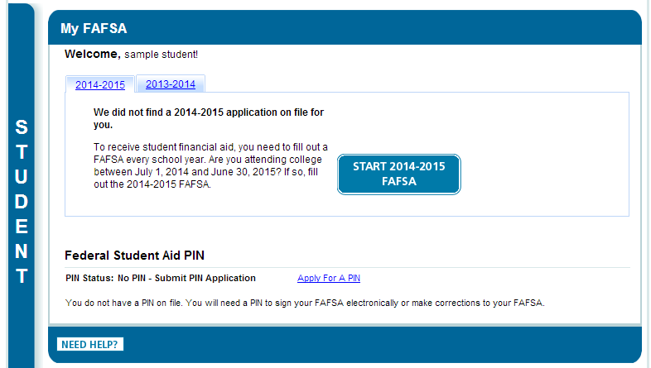

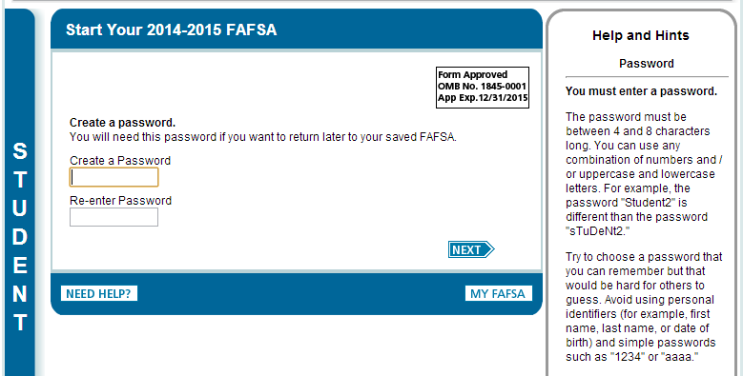

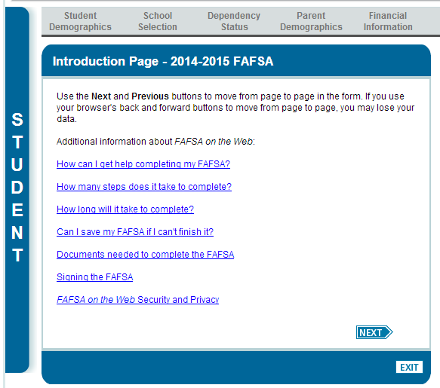

STUDENT DEMOGRAPHIC INFORMATION

- If a student enters an email address on the FAFSA, that will be the SOLE method of communication FAFSA will use with that student. It is very important that the student checks his/her e-mail regularly.
- Students must enter their state of legal residence. For New York State residents this question triggers a link to the TAP application upon submission of FAFSA.
- New this year, after clicking next, a box appears at the top of the page indicating eligibility to apply for New York State aid.

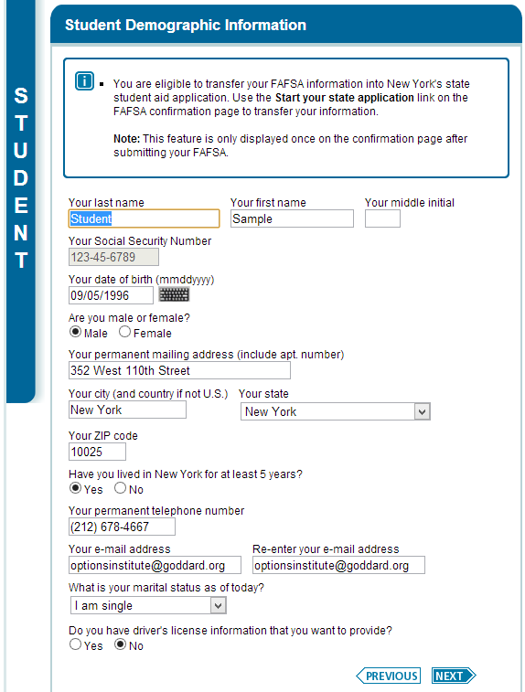
STUDENT ELIGIBILITY
- Students must enter their US immigrant status on the FAFSA. If a student is an eligible non-citizen, he/she will be asked for his/her alien registration number (A number). This number appears on the green card (permanent resident card) or passport (usually stamped there) or on any correspondence the student has received from the United States Citizenship and Immigration Service (USCIS).
- Male students between 17 and 26 must register for selective service (the draft) to be eligible for federal aid. If a young man does not know if he is registered, advise him to click on “register me.” Females will not see this question.
- Students are asked about their parents’ level of schooling. This has no impact on the amount of federal aid received. The government is just gathering information. It has been suggested that this question may be linked to some scholarship opportunities at colleges.
- Students should always say “yes” to being considered for Work Study. It allows them to be considered for the program but does not rope them into anything. They can turn down work study later, once they have seen and considered their financial aid packages.
- Only students who have received federal student aid in the past will see a question about federal drug convictions:

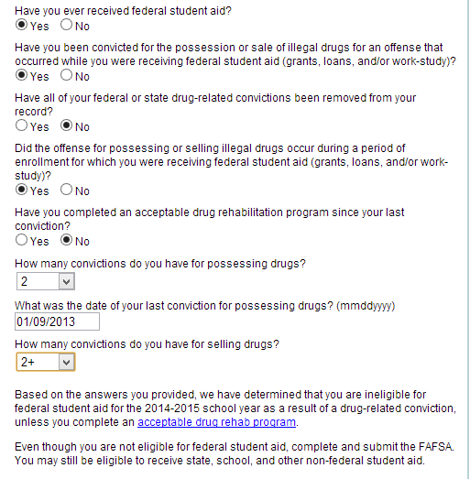

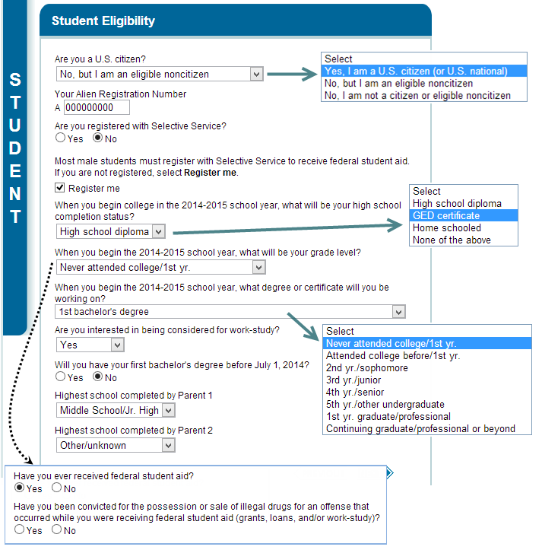

STUDENT ELIGIBILITY CONTINUED

- Students will be asked to input their high school. This will not affect the student’s aid eligibility.

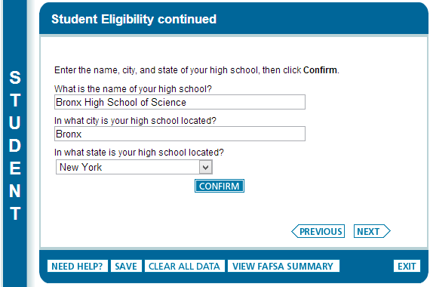

SCHOOL SELECTION

- Students can choose up to 10 schools. If applying to more than 10, students should fill in their first 10 schools (or first 4 on the paper FAFSA), complete and submit the FAFSA. In 3-5 business days, students should log in to FAFSA to see if they have received a Student Aid Report (SAR). When a student receives the SAR and confirms that the FAFSA was successfully processed, it means that the schools he/she listed on the FAFSA have received his/her financial information. Once students receive their SAR, they can delete the schools currently listed and add the rest of the schools they are applying to. NOTE: If students later make adjustments to the information on the FAFSA, they must repeat the process above to ensure that all their schools receive the changes.

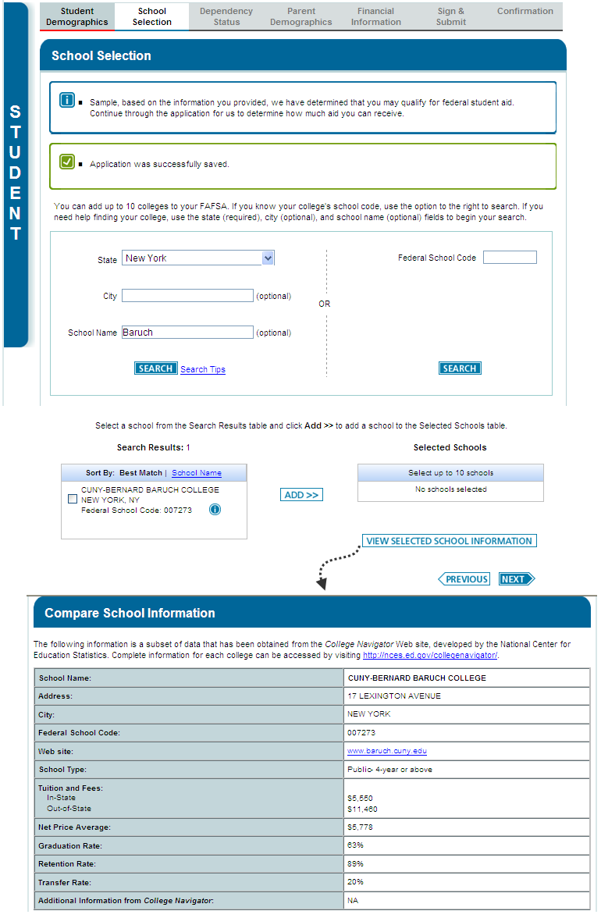

SCHOOL SELECTION SUMMARY

- Students must select a housing plan for each school.
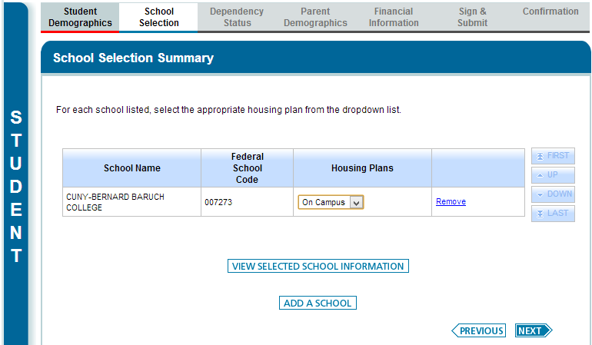

DEPENDENCY DETERMINATION

- Students are automatically independent, if they can answer yes to any of the following:
  - Age 24 and over
  - Married
  - Supporting dependents
  - Graduate student
  - Service in US Armed Forces (engaged in active duty currently or at some point in the past)
  - In legal guardianship
  - Orphan, foster care, ward of court anytime since 13
  - Emancipated minor
  - Unaccompanied homeless youth

- When the student selects yes, more questions will appear, as below:

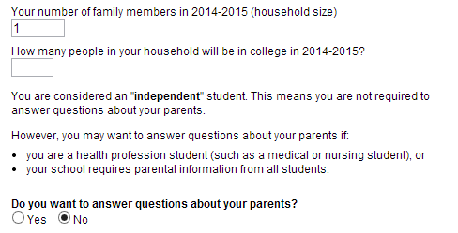

- Students can be determined to be independent through a process called dependency override if they can document involuntary dissolution of family, for reasons such as:
  - Abuse in the family
  - Abandonment
  - Incarceration or institutionalization of both parents
  - Parents lack physical or mental capacity to raise the child

This process can be very complicated and involves successfully making a case to a financial aid officer from at least one college that the student is independent. That officer can manually “override” the student’s dependency status on the FAFSA so that the FAFSA can be processed without parental information and colleges can receive the student’s financial information. Note: Even though the FAFSA is now able to be processed, the student will have to make a successful case to each college from which they hope to receive a financial aid package.
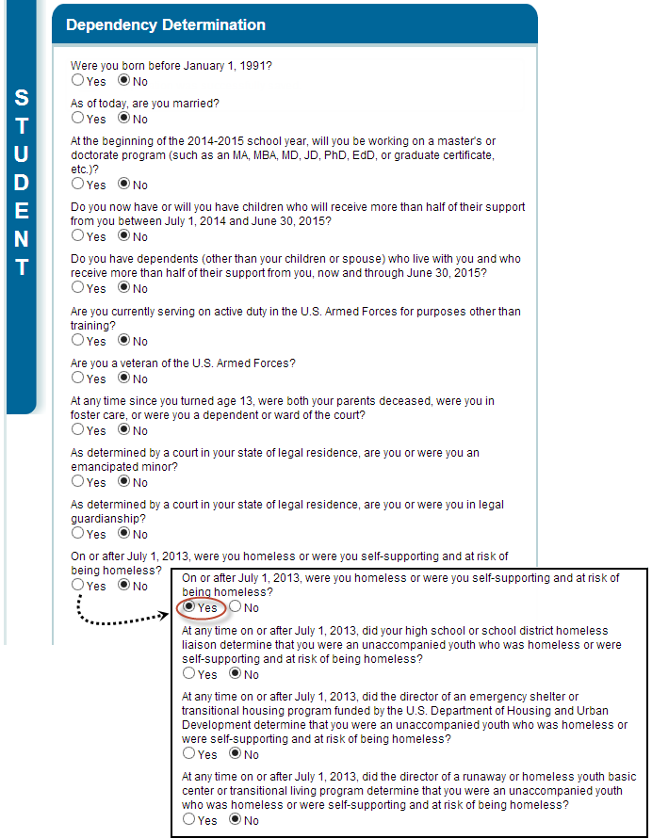

DEPENDENCY STATUS RESULTS

- Who is considered a “parent” on the FAFSA? Biological parents, legally adoptive parents, step parents if currently married to biological or adoptive parents.
- Who cannot be a “parent” on the FAFSA? Grandparents, Foster parents, Legal guardians, Siblings, Uncles, Aunts, Family friends.
- Which parent’s income should go on the FAFSA? If your legal (biological or adoptive) parents are living together, report both parents’ income. If legal parents are divorced or separated, report the custodial parent’s income (that is, the parent the student lived with most, or, if a student lived with both parents equally, it is the parent who provides most financial support). If custodial parent is re-married, the student must report the step parent’s income also.

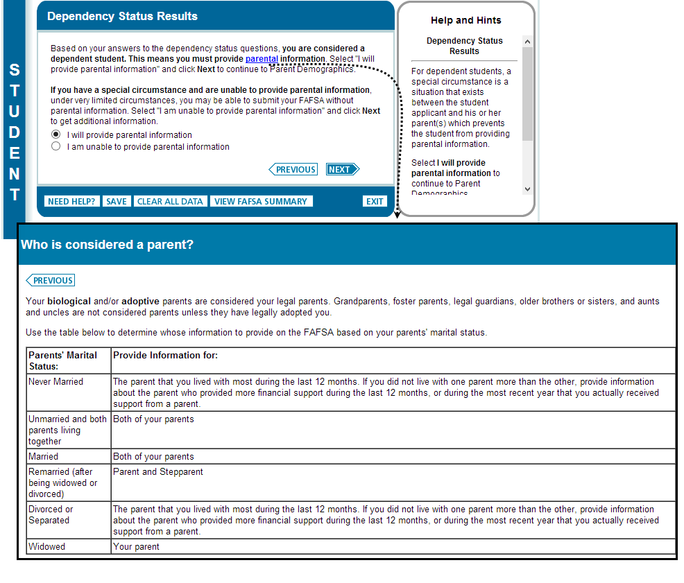

PARENT DEMOGRAPHICS INFORMATION (will be skipped if the student is independent)

FAFSA only cares about the student’s custodial parent. It does not matter who claims the student on their taxes or whether the student’s parents have official divorce or separation agreements.

- For eligible students with undocumented parents:
  - In the parent section, parents should enter all the necessary information and enter 000-00-0000 for their social security numbers.
- If parents don’t have an email address, they can use the student’s email address
- In determining how many people are in the parents’ household, count the parents, all other children who receive more than half of their support from the parents or who would be deemed dependent by FAFSA standards, the student, and anyone else that lives in the same home and is supported by the parents.
- Do not include parents in the question about how many people in the household are in college.
New on the 2014-2015 FAFSA:
- There are two new marital statuses: “never married” and “unmarried and both parents living together.”
- “Parent 1” and “Parent 2” has replaced “mother” and “father.” The sex of both parents is no longer relevant on the FAFSA. For example: if a student has one biological and one adoptive mom who are not married but are living together, both of them should provide their financial information on the FAFSA.

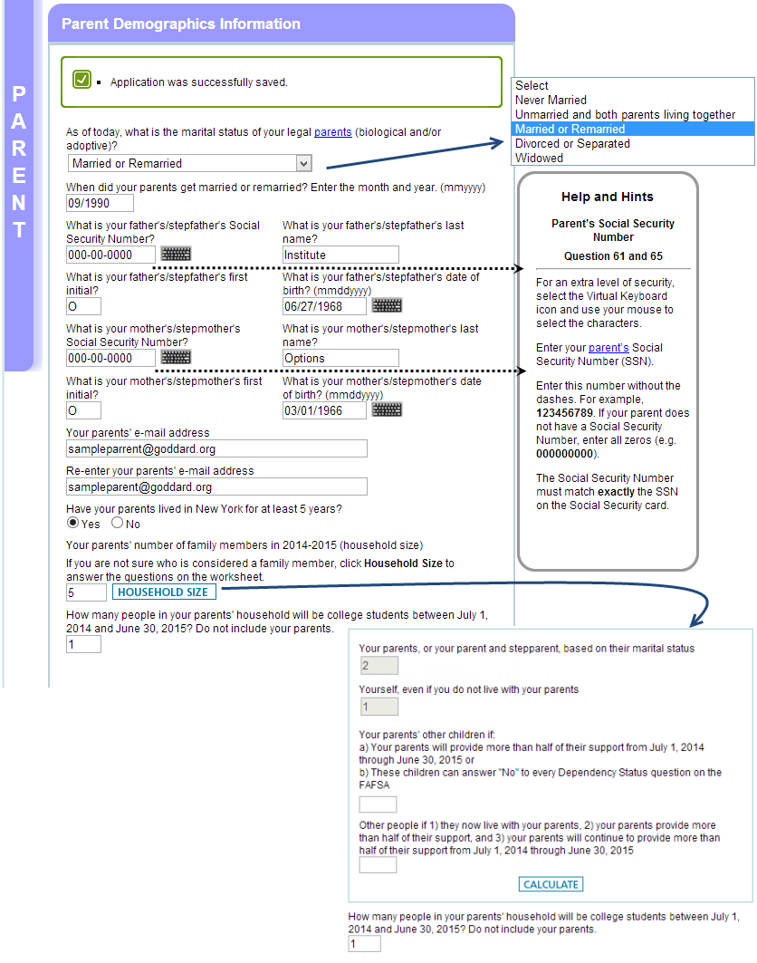

PARENT TAX INFORMATION

- Parents can pre-fill the FAFSA tax questions with their already filed 2013 taxes.
- All of the questions that refer to income tax forms list the line on the income tax forms where you can find the answer.
- In order to make schools’ priority filing deadlines, parents should check the “will file” box and use the previous year’s taxes to estimate figures for the current year. Once their current year taxes are complete, parents can log back into the FAFSA to enter the new information.
- A mismatch between filing status and marital status may mean you cannot use the IRS Data Retrieval Tool.

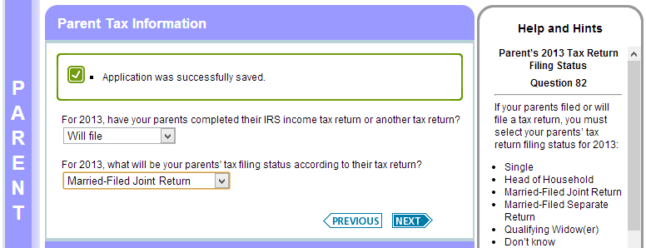

PARENT TAX INFORMATION

- If parents select “Already completed,” they will be given the option to transfer their tax information from the IRS system into the FAFSA system.
- The IRS Data Retrieval Tool is not available until February.

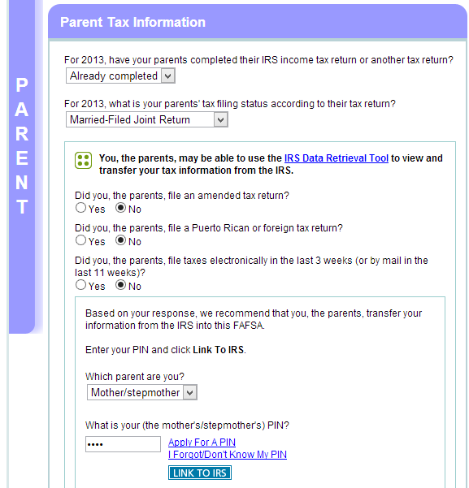

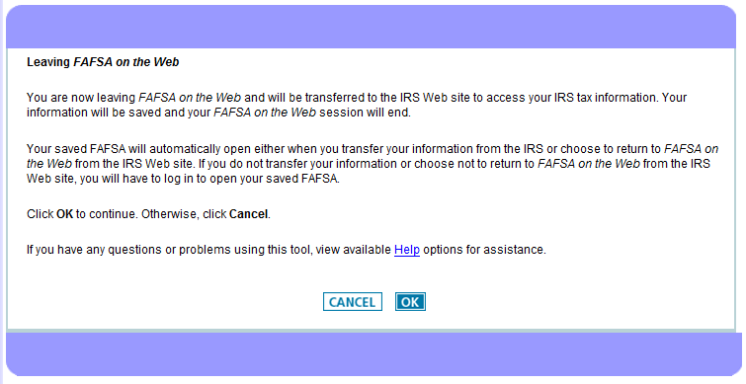
IRS.GOV

- For the IRS link to work successfully, the demographic information entered must be EXACTLY the same as it appears on the tax forms. For example, if the tax form says the family lives on Clinton Avenue, then they must enter “Clinton Avenue,” not “Clinton Ave.”

PARENT FINANCIAL INFORMATION

- The question about how much each parent earned this year from working is a broad question. It means to catch all income earned whether or not it was reported to the government. For the most part, this amount can be found on w2 forms or tax forms. If parents are paid off the books, it is up to the family to determine how much they’ve earned in the year. This question should be answered regardless of whether the family files taxes.
- The dislocated worker question was added to the FAFSA in response to the economic decline. It asks whether the parent is unemployed. Look up the full definition if you think a parent may qualify (in the on-line help boxes or paper FAFSA instructions)

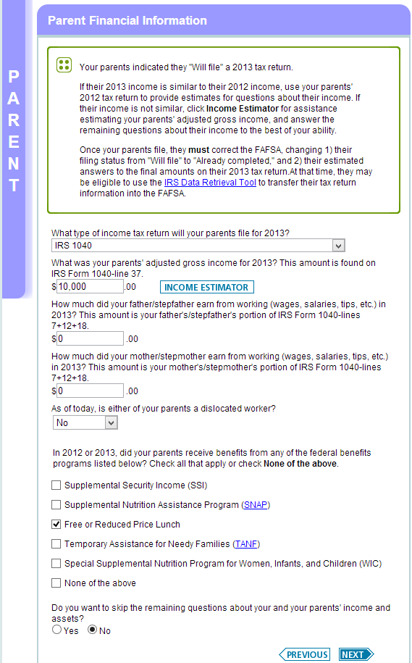
PARENT FINANCIAL INFORMATION CONTINUED

- In determining how much “child support paid” to report, a parent should include child support payments only for children that are not included in the parent’s household size.
- In determining the child support received for all of the children in the parents’ household, do not include foster care/adoption payments.
- When answering questions about the current balance of bank accounts, parents should enter the amount that is left after all of the monthly bills have been paid and food has been bought.
- When answering the question about current business income, keep in mind that FAFSA identifies a “business” as having over 100 employees. If parents own a business that has under 100 employees, they would enter “0” for this question.
- Students are able to skip the remaining questions about the student’s and parents’ income and assets if:
  - Any household member received any of the indicated federal benefit

OR:

  - Parents meet any of the following criteria:
    - Parent(s) filed or was eligible for a 1040A or EZ
    - Parent(s) was not required to file a tax return, or
    - Parent(s) was a dislocated worker

AND:

  - Parents’ 2013 income was less than %50,000
- If given the option, students should skip the remaining questions.

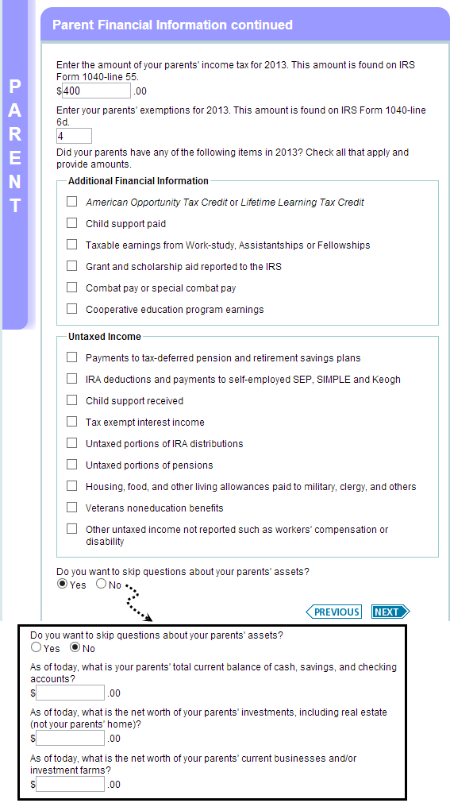

STUDENT TAX INFORMATION

- In large part, students must report their own earnings on the FAFSA. Independent students will fill out this section directly following the independence questions. Dependent students, especially those living in low income households, are often not asked questions about their finances. The questions in this section are similar to the questions about parent income.
- If students earn under $6,260 in 2013, it will not impact their EFC. Students should still report their income.

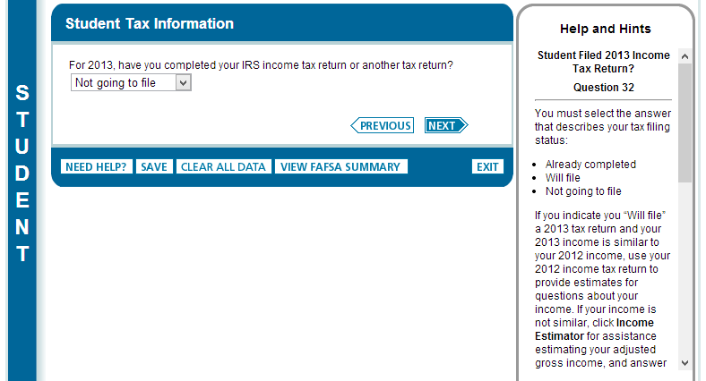

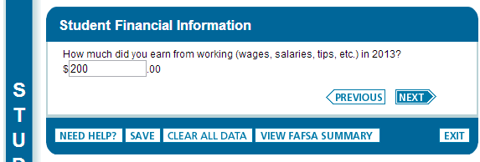

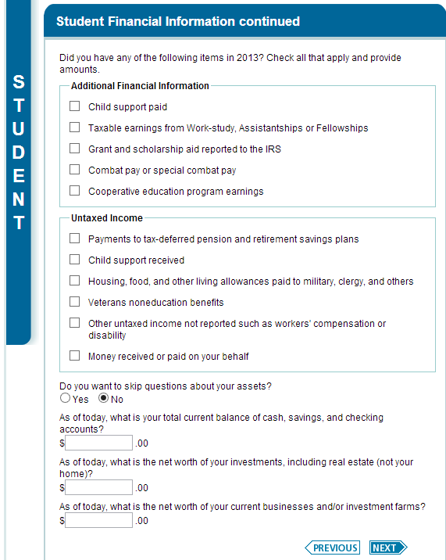

ERRORS

- U.S. Citizens or Permanent Residents with undocumented parents will see this page. Click the CHECK FOR ERRORS button (possibly several times) until the system moves you on to the next screen.

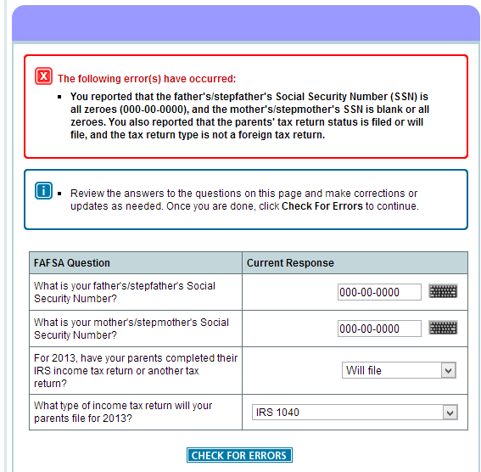

SIGN & SUBMIT

- The student, and his/her parent(s) if the student is dependent, enters their pin numbers. If they have not yet applied for a pin, they can go to www.pin.ed.gov to receive one. Only one parent (even if it is a two parent household) needs to get a pin number to sign the FAFSA. Students and parents (if both are willing) can have the same pin number, so as to have a better chance of remembering it.
- For students whose are eligible for federal aid but their parents are undocumented, the process looks like this:
  - Student will get a pin and use it when signing the FAFSA
  - The undocumented parent(s) cannot get a pin because to do so they need a valid social security number. Instead, when it asks how the parent would like to sign this form, they will select “sign signature page” from the drop down menu. The parent will manually sign the page and mail it into federal student aid.
- Once the FAFSA is submitted, students will see their Expected Family Contribution (EFC), and estimated Pell and Direct Stafford Loan amounts, as well as info about all of the schools they have applied to. Additionally, there will be a link for New York State Residents which leads to the TAP application.

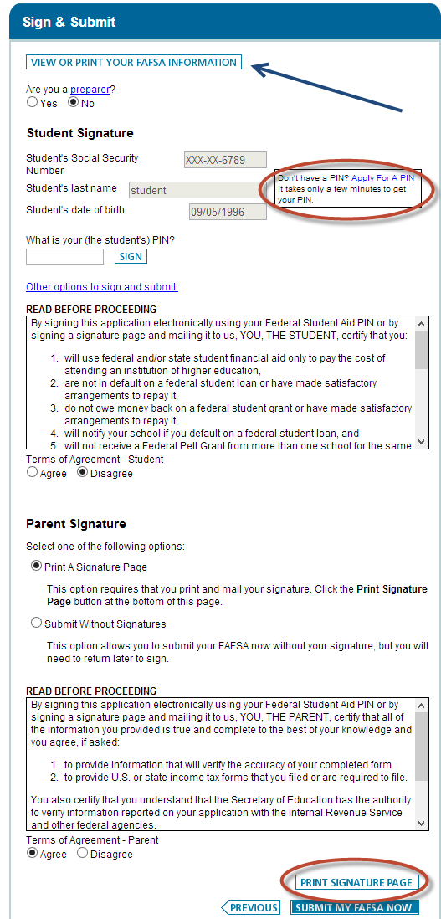
SIGNATURE PAGE

- Undocumented parents of U.S. Citizen or Permanent Resident students are not eligible for PIN numbers. Therefore, they will sign and mail this signature page. The student’s FAFSA is not complete without this submission.

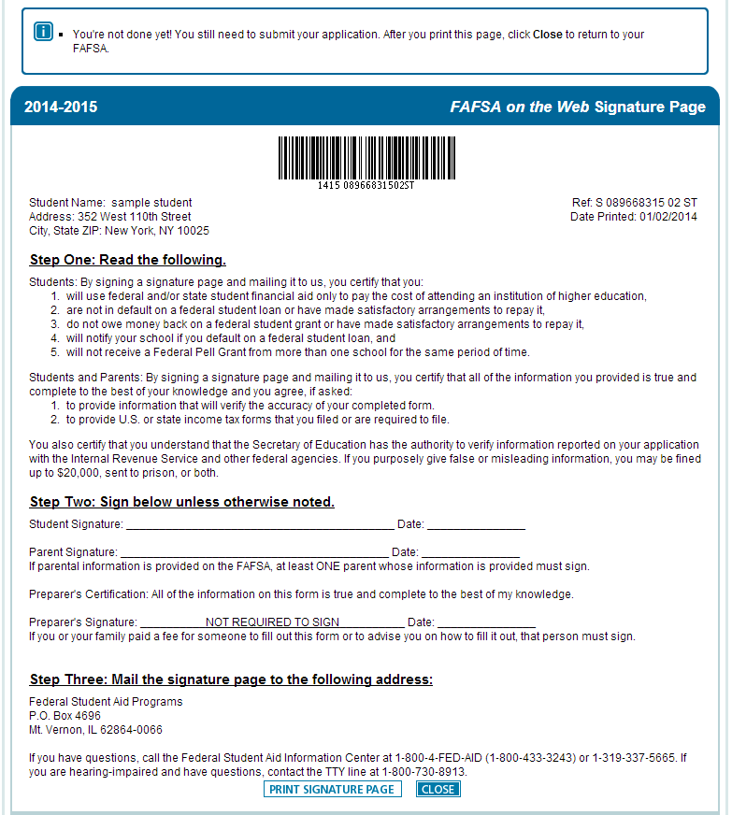
SUBMISSION CONFIRMATION PAGE

- If parent and student were both able to sign electronically, the confirmation page will include a link to file the state application (TAP) form as shown on the opposite page.

- Our mock student’s parents are undocumented, so they would have to mail in their signature page and the TAP link would not yet be available. That student must wait until the signature page is processed to complete the TAP application.

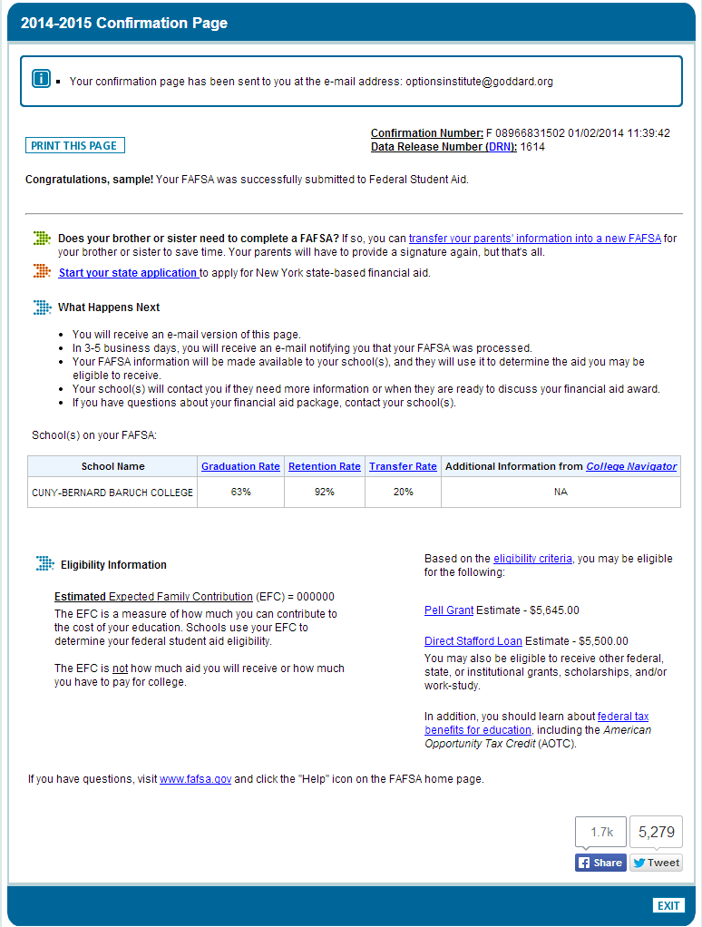

STUDENT AID REPORT

- The SAR contains the student’s estimated EFC.
- The SAR will call attention to any major errors on the FAFSA in one of the first few pages.
- The SAR can be accessed on-line using a PIN, by clicking on “View and Print Your Student Aid Report.”

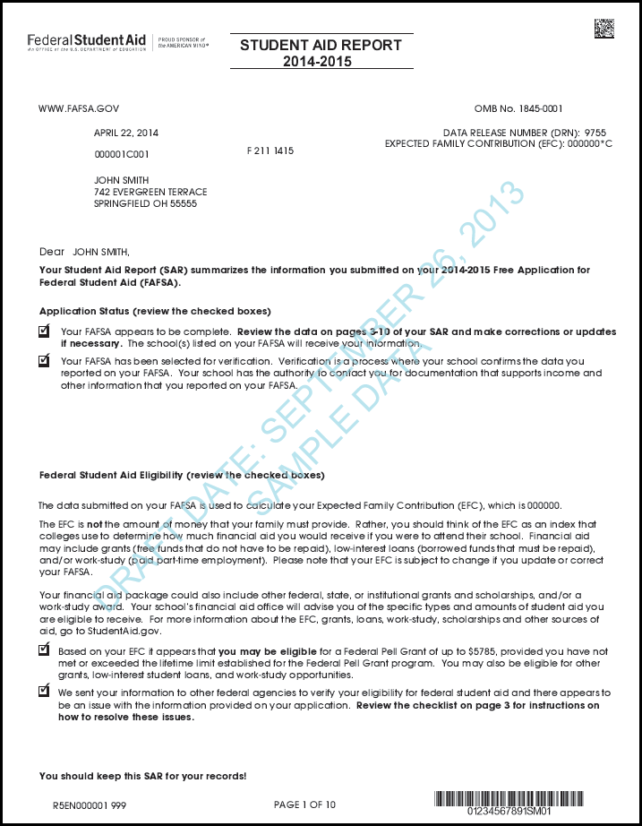

STUDENT AID REPORT CONTINUED

- After a student applies for the FAFSA and it is processed, they should review their Student Aid Report (SAR) and correct any errors they find. The SAR contains a complete summary of all the financial information the student provided on their FAFSA application. Students should check the “comments” section of the SAR to ensure their FAFSA was successfully processed. They should also remember to update their SAR if they initially filed with estimated figures based on the previous year’s taxes.

NOTES ON THE VERIFICATION PROCESS
- Each year at least a third of all students will be asked to verify the information they reported on the FAFSA.
- Usually the college’s financial aid office will request a copy of signed tax returns that were filed by the student and/or parent.

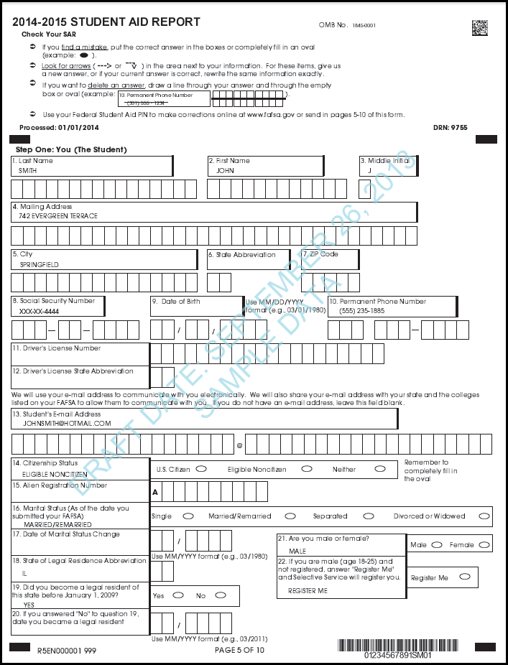

QUIZ YOURSELF
on the FAFSA

- Christina is a high school senior who has a drug conviction.
Will she be eligible for financial aid? Why?

- Mara has priority filing deadlines of February 1st. Her parents won’t have their 2013 taxes done until at least February 15th.
When should she submit her forms? How would she do so?

- Alta’s family owns a store that employs five workers.
How would they report their store’s profits?

- Nick is a US citizen whose parents are undocumented.
Should his parents put information on the FAFSA? If so, how would they do so?

